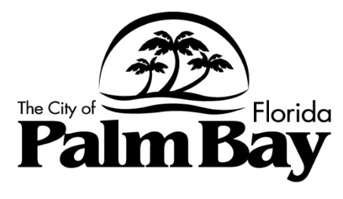

# AGENDA

# SCHOOL ZONE SPECIAL MAGISTRATE

# Meeting 2025-02

# June 3, 2025 – 10:00 AM

# Palm Bay City Council Chambers

# 120 Malabar Road, SE

## CALL TO ORDER:

## SWEARING IN:

**PUBLIC COMMENTS:**

## ADOPTION OF MINUTES:

**1. Meeting 2025-01, May 13, 2025**

## HEARINGS:

2030800047267257 FRASER, ANN-MARIE SPEED VIOLATION

2030800047593396 THOMAS, MONIQUE SPEED VIOLATION

2030800047412643 SERRANO, ALBA N SPEED VIOLATION

2030800047311690 HADDADIN, JOHN SPEED VIOLATION

2030800047213868 EISKANT, SHANNON SPEED VIOLATION

2030800047382462 MARFISI-BAYLIS, MILAG SPEED VIOLATION

2030800047604936 BLANKMAN, NICOLE M SPEED VIOLATION

2030800048728695 LE, DANIEL NHAN SPEED VIOLATION

## ADJOURNMENT:

**If an individual decides to appeal any decision made by the Special Magistrate with respect to any matter considered at this meeting, a record of the proceedings will be required, and the individual will need to ensure that a verbatim transcript of the proceedings is made, which record includes the testimony and evidence upon which the appeal is based (FS 286.0105). Such person must provide a method for recording the proceedings verbatim.**

**In accordance with the Americans with Disabilities Act, persons needing special accommodations for this meeting shall, at least 48 hours prior to the meeting, contact Code Compliance at (321) 952-3430 or Florida Relay System at 711.**

**If you use assistive technology (such as a Braille reader, a screen reader, or TTY) and the format of any material on this website or documents contained therein interferes with your ability to access information, please contact us. To enable us to respond in a manner most helpful to you, please indicate the nature of your accessibility problem, the preferred format in which to receive the material, the web address of the requested material, and your contact information. Users who need accessibility assistance can also contact us by phone through the Federal Information Relay Service at 1-800-877-8339 for TTY/Voice communication.**